# Custom Program Design Report

Name: Tonny Wijaya

Student ID: 101225545

# Game Summary

Maze Runner is a game where you are placed in a maze and you are asked to find a key to unlock a chest before being able to go out from the door placed differently for each. You will be given time to unlock a chest before running towards the door. Maze can be customize using the map.txt file given in the folder. The level of the game can be determined before playing (hard, medium, easy). Game will be recorded of time taken after the game ends if you win in recordwin.txt.

# Pictures of the game

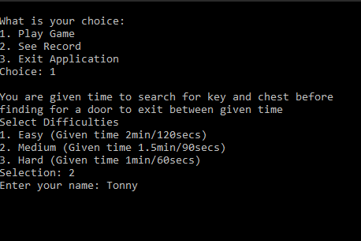

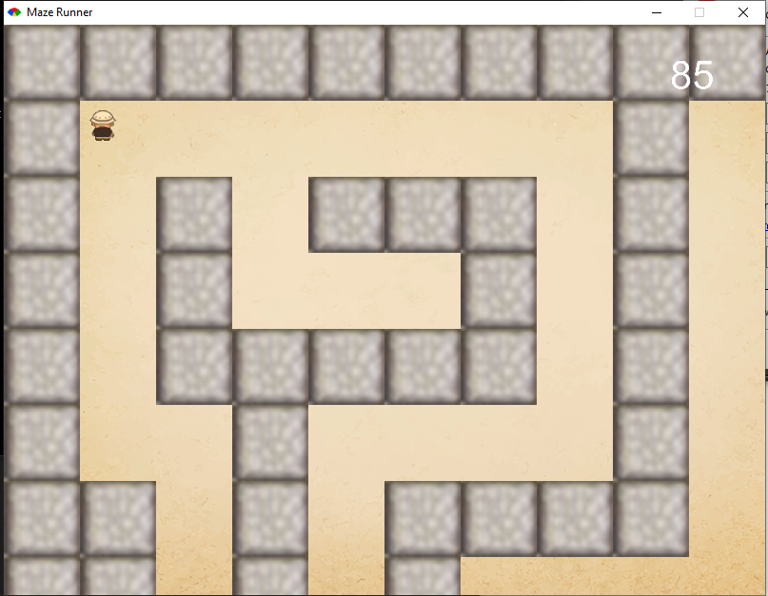

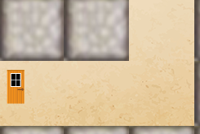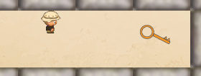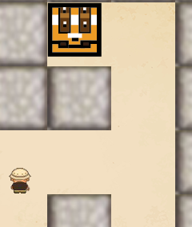

# Main data types

|  |  |  |  |
| --- | --- | --- | --- |
| Field Name | Data Type | Description | Example of value |
| start_x,y | Integer | Coordinate of the player | 50,530 |
| @nochest | Integer | Number of chest | 0 (begin) |
| @nokey | Integer | Number of key | 0 (begin) |
| @second | Integer | Second countdown | 120,90,60 secs |
| @walls_arr | Array | For making walls | [nil,nil,nil] |

# Main functions

|  |  |
| --- | --- |
| Function /Procedure/Method | Description |
| Initialize | Size of our window, declare variables, ask for difficulties |
| draw | Draw anything like walls or person or key |
| update | Walking person, chest animation, key taken, and collision checking |
| button_down | What happened when button is pressed. |
| ask | Ask for difficulties |
| main | For making options before starting the game |

# Custom Data Types

|  |  |  |  |
| --- | --- | --- | --- |
| Field Name | Data Type | Description | Example of value |
| Map | Array | To create map for the maze (width,height,row,column) | Map.new(80, 80, 20, 20) |
| GameObject(minigl) | Set of properties | To create image without gosu::image and determine its bound | GameObject.new(@start_x, @start_y, 28, 28, :runner, Vector.new(0, 0), 2,2) |
| Vector(minigl) | coordinates | Location for initial GameObject in case of bounds? | Vector.new(0,0) |
| BgUtils::TiledImage (bg_utils) | Image | Change image/texture/color for the walls | BgUtils::TiledImage.new(File.dirname(__FILE__) + "/media/wall.png",80,80) |
| set_animation(minigl) | integer | Change animation of GameObject (1,2,3,4) | @sprite.set_animation 0 |
| Bounds (minigl), intersect? | True/false | Determine bound of the game object | @door.bounds;  if @door.bounds.intersect?  command  end |

# Flowchart of the game

